UNITED STATES MILITARY ACADEMY

JCUSI:

2012 FINAL REPORT

EE402

I1

COLONEL SADOWSKI

BY

CADET HAMMOND, PATRICK ’12, CO D2

CADET HURLOCK, GREGORY ’12, CO G3

CADET LU, GRACE ’12, CO G4

CADET RUS, GRIGORIU ’12, CO E2

CADET SAW, ANTHONIO ’12, CO D3

CADET STARCK-KING, NICOLAS ’12, CO C2

WEST POINT, NEW YORK

11 MAY 2012

___MY DOCUMENTATION IDENTIFIES ALL SOURCES USED AND ASSISTANCE RECEIVED IN COMPLETING THIS ASSIGNMENT.

___NO SOURCES WERE USED OR ASSISTANCE RECEIVED IN COMPLETING THIS ASSIGNMENT.

SIGNATURE:________________________________________________

**JOINT COOPERATIVE UNMANNED SYSTEMS INTIATIVE: LAND INTIATIVE 2012**

*Justin A. Bucher, John C. Fernandes, Patrick R. Hammond, Gregory M Hurlock, Fang J. Liu, Samuel S. Lough, Christopher J. Nelson, Grigoriu O. Rus, Anthonio K. Saw, Nicolas G. Starck-king (COL Bob Sadowski, LTC Paul Maxwell, MAJ Dominic M. Larkin, MAJ Christopher J. Lowrance), Department of Electrical Engineering and Computer Science, United States Military Academy, West Point, New York 10996*

Conducting military missions risks lives and requires manpower. The military has begun employing remotely controlled assets, especially in high risk scenarios, in order to reduce the cost of conducting operations; however, current systems still require personnel to control each system. The Joint Cooperative Unmanned Systems Initiative (JCUSI) furthers this objective by pursuing systems that can conduct military tasks through an autonomous or semiautonomous network of land, sea, and air assets. JCUSI tailors its efforts around a specific scenario. In this scenario a target approaches by water and begins moving over land. The assets identify and track the target from land, water, and air. In order to accomplish this scenario, the land portion task is primarily point reconnaissance. In order to conduct this reconnaissance, the robots receive a series of waypoint from a command center and moves along these waypoints using obstacle avoidance algorithms. Additionally, the robot provides a camera feed to the Service Command Center to provide operational context. The robots also retain a manual override function, because our goal is to reduce the manning needs, which does not preclude the possibility of manual control for a more flexible and safe system.

**Problem Statements:**

*Overall Problem Statement:*

Develop a network of aerial (USAFA), naval (USNA), and land (USMA) semi-autonomous robots that share operational data through a Joint Command Center (JCC) to collectively reconnoiter a region and track a designated target.

*West Point Specific Problem Statement:*

Develop two ground robots that will be able to detect, locate, and advance on a designated target as directed by a Service Command Center (SCC) and provide current status information to a Joint Command Center (JCC) in order to contribute to a joint service Common Operating Picture (COP).

**Concept Sketch:**

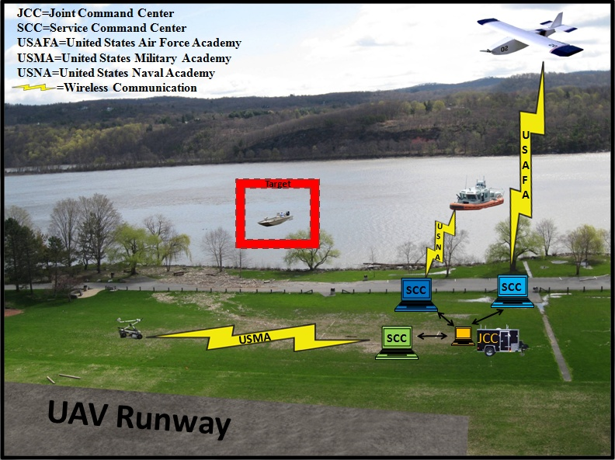

**Specifications:**

*Interface Requirements-*

* **JCC**
  + Establish network communication with Service Command Centers (SCC)
* **SCC**
  + Establish wireless communication with the PackBot from the OCU
* **Robotic Platform (PackBot)**
  + Hokuyo laser interface with PICO through ROS module , CAT5 cable, and serial connection
  + GPS interface with PICO through ROS module and serial connection

*JCC Functional Requirements-*

* Receive the robots’ state and sensor data from the SCC’s (USMA, USAFA, and USNA)
* Track the robots’ states and JCC state
* Publish data/information to SCC’s
* Display system state and appropriate information to the user
* Common Operating Picture at JCC for situational understanding by all operators

*Robot Functional Requirements-*

* Autonomous and teleoperations modes
* Communicate state to Command Center
* Communicate sensor data to Command Center
* Provide video feed of environment

*Performance Requirements-*

* **Network**
  + Transmit video feed/ sensor data from robots to JCC at least 200m
* **Laser Range Finder**
  + Detect and identify obstacles/ personnel up to 10 meters from robot
  + Have scanning area of at least 180 degrees
* **Physical Robot Considerations**
  + Be able to traverse grass, gravel, and sand areas
* **Weather Conditions**
  + Water resistant
  + Operating Temperature Range -20F 🡪120F (MIL-STD-810G)
  + Sand resistant
  + Shock resistant

**Block Diagram:**

Below is the diagram of the JCUSI package that was added to the PackBot, eliminating the use of microcontrollers and utilizing stock antennas for communication were a way the 2012 project increased efficiency and decreased opportunity for systematic error.

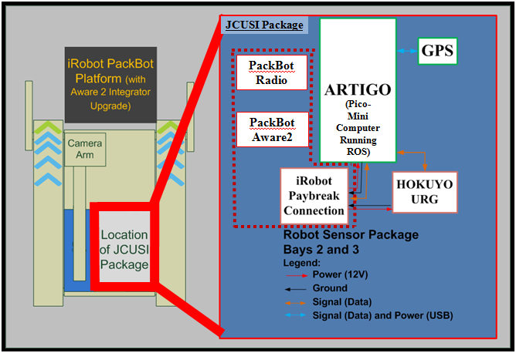

Below is the flow of information through the JCUSI, West Point specfic system, as data is collected, passed, and finally parsed into useful information for the operator.

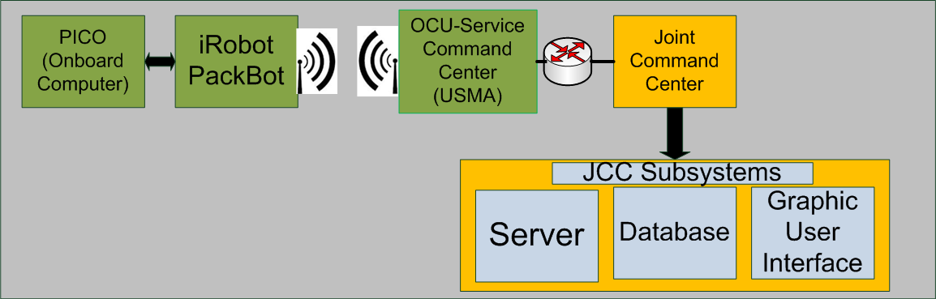

**Results:**

*Sensor Suite*

The sensor suite included a Garmin GPS, OS5000 Compass, and a Hokuyo LRF. The GPS and compass are the two key pieces for the PackBot’s navigation. The GPS is needed in order to provide accurate position data to the PackBots, while the compass provides the bearing. Both of these sensors were successfully implemented into the PackBot platform through the use of an Artigo computer. Table 1 shows an example of the test data taken from the GPS.

|  |  |  |  |
| --- | --- | --- | --- |
|  | Output | Test Board | GPS and Pico |
| Latitude | 27° N | 26.9999226° N | 27.000035° N |
| Longitude | 86° E | 85.9999511° E | 86.000022° E |
| Altitude | 0 ft | 99 ft | 23.47ft |

Table 1: GPS Test Data

The GPS provided accurate readings that were used for the autonomous navigation algorithms. The compass provided accurate bearings within ±2o. Placement and use of these sensors was critical. We found that placing the GPS below the tracks of the PackBot would cast a shadow and disrupt the GPS from acquiring a satellite lock. However, once elevated, the GPS would achieve a satellite lock very rapidly. The compass readings were obviously best under ideal static conditions. Unfortunately, the motion of the PackBot caused a considerable amount of vibration that significantly degraded the compass bearing, sometimes by up to 100o. Therefore when actually implementing the compass we had to make sure that the PackBot remained stationary while a bearing was taken. To do this we had the robot pause for one second to take the heading before navigating. After debugging these issues, we were able to successfully implement these two sensors.

The Hokuyo LRF was used for obstacle avoidance. The obstacle avoidance would be present in only autonomous modes. Obstacle avoidance would only be dependent on whether or not the PackBot was in forward motion. Because the PackBot turned within its own radius it did not need to try to detect obstacles while turning. The LRF and obstacle avoidance algorithm were successfully implemented. We found that in application, the LRF would sense objects that were approximately 5ft away. Once sensed, the PackBot would attempt to make a left turn to avoid what was in front of it. After clearing the obstacle, the PackBot would reorient itself toward the target and continue its navigation.

*Autonomous and Teleoperations Modes*

Our design called for two different types of operation – autonomous and teleoperation. During autonomous operation, the platform would first receive a GPS coordinate from the SCC. Next, using the received the coordinates, the PackBot would calculate a straight line distance from the target based on the attached Garmin GPS reading. This calculated distance combined with the bearing provided by the attached OS5000 compass would provide the PackBot with the information it needed to achieve autonomous navigation. During teleoperation, the PackBot would receive a keyboard commands from the SCC. These commands would be translated and the PackBot would execute the command based on a series of preloaded movements, including arm and camera functions. The command set was the same as it would have been in the PackBot’s standard operating mode.

For our final design both autonomous and teleoperation modes were achieved. Both PackBots were successfully able to take a GPS coordinate and autonomously navigate to the target. However the navigation aspect was very slow, partly due to an internal speed restriction that we set. In addition, because of the vibrations associated with traversing uneven terrain, the PackBot consistently had to stop in order to take an accurate compass bearing. Despite this minor issue, the PackBot eventually made its way to both an intermediate checkpoint, and the target destination. Based on the navigation algorithm, the PackBot would travel until it was inside a 5m window, at which point it would stop and consider itself at the target location and execute a predetermined pose. Due to communication speeds and bandwidth, teleoperation commands had about a 1sec delay. However, we were successfully able to send each PackBot keyboard commands for teleoperation. With minimal practice it was possible to operate the PackBot as normal using the keyboard commands. Both chassis and arm commands were accepted.

*Communicate State and Sensor Data to Command Center*

A key aspect to the project was to receive information from the robot at the SCC and JCC levels. This information covered state and sensor data. State data was to include things such as latitude, longitude, and bearing. The sensor data would come from the robot and include speed, orientation, and battery life at the SCC and pass video feed to the JCC level. The state information and sensor data would provide the operators at the SCC and JCC level with valuable information in order to continue to conduct unmanned operations. The state information was successfully transmitted. Both the SCC and JCC were able to see, in near real-time, the location and heading of both robots. The sensor data however did was not sent from the robot. During our integration process, we ran into numerous issues that prevented us from pulling out the sensor data and transmitting it to the SCC and JCC. However, we felt that this information was not a priority. Although this would be part of the ideal solution, the sensor data from the robot would not be necessary for us to achieve a baseline solution and navigate to our target location.

*Provide Video Feed of Environment*

A live video feed is critical to unmanned systems. For our design we used the video feeds that were being transmitted from the original PackBot systems. We used this because it was already part of the information being wirelessly transmitted from the robot, and because the PackBots use very robust camera systems. These camera systems provided us from one to five cameras which ranged from regular, to thermal, to regular with 10x zoom capabilities. Each one of these cameras was able to be accessed during operation of the PackBot in both autonomous and teleoperation modes and steamed in real time. This allowed us to monitor the movements of the PackBot while it navigated to a target, or monitor the movements we were sending it during teleoperation. The video feed was transmitted only to the SCC. For our initial design we felt that this was the only part of the information chain that critically needed the feed. In the future, the ideal solution will have the video feed transmitting to the JCC. However, because of bandwidth and multiplexing issues, we felt that this was not a high priority for the first version of the project.

*Target Identification*

Target identification was part of our ideal specifications. However, upon execution of the project, we found that this was a very high level requirement. We felt that it was necessary to achieve baseline autonomous operation and teleoperation before moving to target identification. Therefore we were not able to implement target identification, but with the functionality that we have achieved with the current system, we believe it is a feasible objective for the future.

**Pictures:**

Below is the additional hardware and custom packaging that was used on one of the two PackBots utilized for the JCUSI Project.

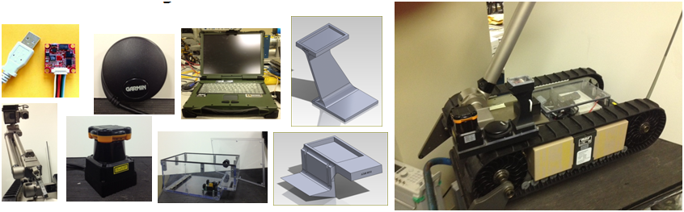

The same hardware and packaging seen above (except for the upgraded arm for additional viewing capabilities) was used on the other PackBot as seen below in a slightly different configuration.

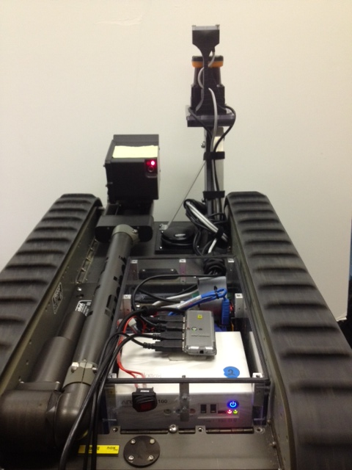

Below is our before and after photos of the factory configured PackBot versus the PackBot modified with the JCUSI package.

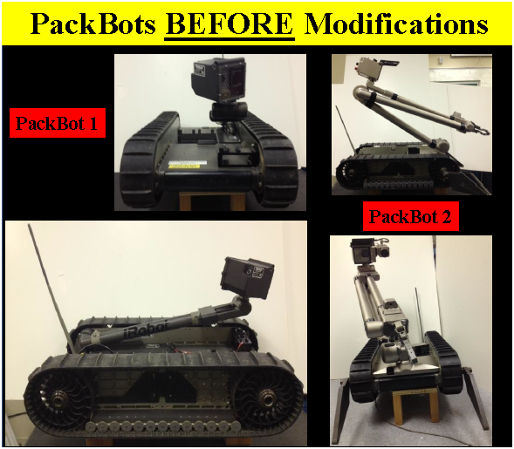

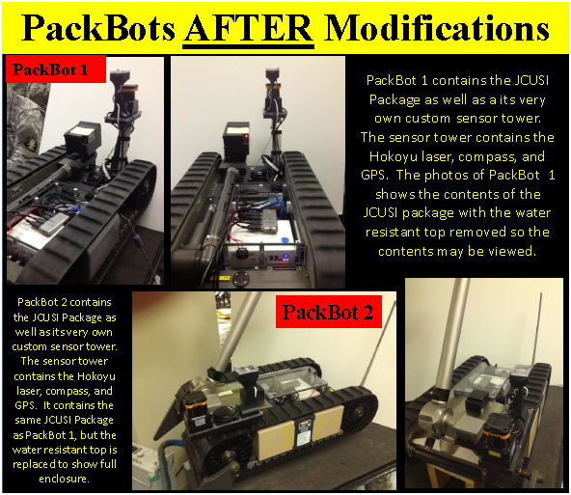

Finally, below is a picture of the 2012 JCUSI project team after a long night of preparation the night before projects day.

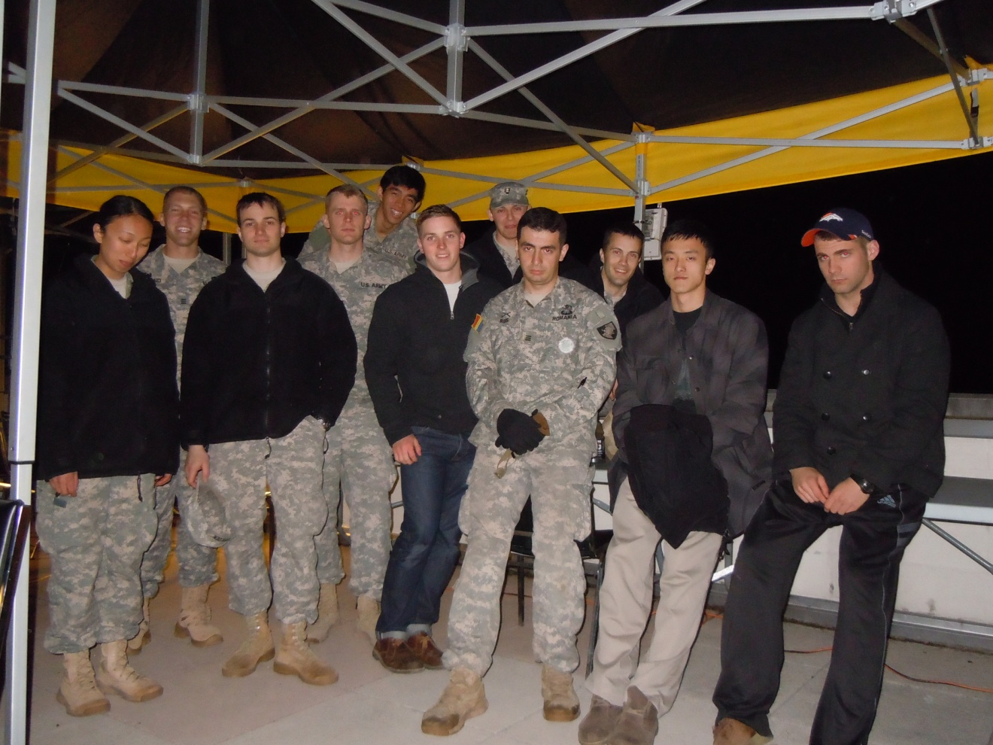

From left to right: *Grace Lu (EE), Patrick Hammond (EM-Project Manager), Greg Hurlock (EE), Nick Starck-King (EE), Anthonio Saw (EE-Functional Manager), Sam Lough (CS), Justin Bucher (IT), Rus Grigoriu (EE), JC Fernandes (CS-Functional Manager), Fang Liu (CS), Chris Nelson (IT-Functional Manger)*

**Recommendations for Future Work:**

*Patrick Hammond:*

Coming from the Systems Department and having an interest in having a future in Project Management this was a great opportunity for me. I would defiantly recommend having a project manager again next semester and if the other two academies do not have one appointed they either need to, or the West Point PM should be put in charge of managing the entire project as whole. With the following recommendations for improvements for next year and the probable increase of interactivity between the three service platforms there will need to be more meetings for work time to develop the project and they will have to be done early. The meeting we had early first semester was crucial in the success of the project and without that meeting coordination of the three academies with respect to integration of systems on projects day would have been much more difficult. There were also way too many people allotted to this project and could easily be cut back to make the team more efficient causing less issues when it came to integration of hardware and software, coordination for tasking, etc., and less informed people on the project. I believe that the project could be done with 3 Electrical Engineers, 2 Computer Science, 1 Information Technology, and 1 Engineering Management major. This would make the project more efficient because it would keep from spreading work and knowledge so thin across the project and it would decrease slack in the project when people have nothing to work on and other tasks need to be completed before they can continue on anything else on the project. This would also free up people for other projects that may need more people which would help the other projects out and also give those individuals the proper chance they deserve to learn as much as possible on their capstone.

*Greg Hurlock:*

My subsystem could use three improvements, two concerning the video feed and the other with the controls. As mentioned earlier, the video feed was not transmitted to the JCC. We determined that it wasn’t a critical aspect of the project, but it would be something that is nice to have implemented. Along with the transmission of this video feed will come the multiplexing of the feeds coming in from the other robot, the UAV, and boat. Also mentioned earlier was target identification. Now that the video feed is running and transmitting, the implementation of target identification would be a large step in this project. This would give the system an added level of awareness. The packbot can already sense whether or not it has made it to a target area, but giving it the capability of target identification would allow it to determine whether or not it was in the right spot. Additionally, target identification would allow the packbot to specifically approach the enemy once it has made it to the general location.

The controls only need minor improvements. We were able to send keyboard commands and a program is set up that translates the joystick commands into keyboard commands. The only thing that is currently lacking is the connection between these two points. Once this connection is made, the user will be able to control the packbot through a gamepad.

*Nick Starck-King:*

With the foundation that was established this year there were a great deal of possibilities that are opened up for future work. Currently the basic operation of the robot, with full access to the capabilities of the PackBot platform, additional functionality will easy to expand on next year. I think that with the addition of some simple sensors and commands a great deal of autonomous functionality. With the addition of an accelerometer you could add autonomous tilt detection and self-righting. With chassis data you could work on adding retro traverse, and automated return-to-base functions if a connection is lost. These functions are being worked on in major government labs and in industry as we saw at the NDIA conference in San Diego and I think it would be valuable to explore for the future team. The addition of the standard PackBot controller for use during manual operation would also be something to include for future work. We could also improve the system by transmitting sensor data back to SCC/JCC. This would allow for options such as running SLAM algorithms indoors and outdoors and give this view to the commanders at the SCC and JCC. Implementing the tilt mount for the Hokuyo to do 3D mapping if the Velodyne produces too much data for the PICO. Next year’s group can also look into improved computing on the PackBot to accept new sensors like the Velodyne.

On the CS side, target identification and tracking could be added now that we have access to the camera feeds coming off of the PackBot. Improved resiliency in the network would be good. Having the PackBot set to boot settings so that we don’t have to have the system connected to run commands every time the PackBot gets power cycled would increase efficiency and waste less time during testing. It would be nice to use the kill switch, turn the system back on and be able to connect to the PackBot from the SCC. Next year’s group can also work on refining and adding functionality to the GUI. Transmitting the target coordinates from JCC to SCC autonomously as opposed to doing that handoff manually. And the biggest CS challenge I think would be implementing 1 SCC to multiple PackBots. This was one of the big concepts that they were looking forward and from what I know now about the system I think it would present a fairly significant challenge but would also be very impressive if they were able to get functioning.

*Grace Lu*:

The current system could be improved by performing additional system upgrades, especially in the PICO. For example, our use of the laser range finder was limited by the processing processor of the PICO: we were unable to implement the three-dimensional Velodyne component because the PICO physically couldn’t handle it. Moreover, the compass had sensitivity issues, as rocky or ragged surfaces would cause debilitating fluctuations in our compass readings. To improve on this issue, we could attempt to find a more rugged and stable compass. On the other hand, we could look into filtering algorithms that would negate the fluctuations in compass readings.

*Anthonio Saw:*

The system can be improved by having all systems act cooperatively with one another without human control. It would be “nice to have” all systems operate and adjust accordingly based upon their received input from each other. I recommend for next year’s focus to be on improving the navigation and obstacle avoidance algorithm. The compass can also be looked into for improvement because of its relative high sensitivity to the rocky terrain shown when testing on the rivercourts. Another area of improvement can be placed on enabling the capability of mapping the terrain in order to facilitate self-navigation. The terrain can be mapped by the laser range finder. Another area of improvement can be to upgrade the Artigo Pico processor in order to be able to handle the Velodyne 32E laser range finder. The Velodyne’s 3D mapping as opposed to the Hokuyo’s 2D mapping would serve the robot much better in regards to obstacle avoidance and terrain mapping.

*Grigoriu Rus:*

JCUSI should definitely be continued in the following years mainly because there is room for improvement. From the hardware side of things the next year’s project could use different platforms, other than the PackBots. A true challenge for and EE major would be to build the platform from scratch but still maintain it to the same standard as the PackBot (milspec). Different sensors can and should be used. We recommend using the Velodyne 32 but with a larger platform—something that would offer the lidar more clearance from the ground. Furthermore, we recommend using a different compass that can be easily stabilized and does not take much interference from vibration of shocks. And last but not least, we recommend using a new, better compass—something that would offer a lock time under 30 seconds (such as the LS20031 GPS). From the software side of things, we recommend that the Haversine formula should be maintained for calculating distance and forward azimuth but Kallman filtering should be implemented in order to get stable and more realistic sensor results. This would eliminate the “drunken sailor” movement pattern that GPS navigation robots display when using a simple algorithm—they tend to overshoot the adjustments.

**Social, Political and Economic Considerations:**

The global market for unmanned ground vehicles is a growing field with the United States Army deploying thousands of robotic systems every year. However, the market is sensitive to encompassing social, political, and economical factors. The growing need for homeland defense and the safety of the soldiers are driven by the political entities which govern the deployment of robotic systems, management of robotic systems integration into combat units, and the international political relationships that are factored when concerning liability on autonomous and semi-autonomous robotic systems.

***Social Considerations***

From a social perspective the biggest challenge that robotics projects always had to face is the people’s acceptance of the fact that a machine can be semi or fully autonomous and can operate on its own. The greatest concern is safety. Hollywood has several motion pictures such as *The Terminator* or *I Robot* that illustrate people’s greatest fear of robots: what if they take over? We can probably safely assume that we are far from developing machines of such intelligence capable of adapting to new situations and performing such complicated tasks such as taking over the world…but we can also certainly state that we are at the point where our robots can be considered autonomous. The two JCUSI PackBots were rugged and safe from the very beginning given the fact that we based our entire project on finalized, DOD employed platforms. However, our additions were the ones that potentially could take the control capability from the operator. The PackBot is heavy, powerful and capable of moving quickly, so our only safety consideration was not hitting anybody. In the worst case scenario, the robot can be stopped wirelessly from the SCC and if that does not work, we also mounted an emergency kill switch on the back of both custom made JCUSI boxes. Furthermore, during our testing we blocked off the main access ways to the testing area and we informed the locals nearby about the project and the potential risks.

***Political***

Given the small nature of our project, politically we might not attract a lot of attention. The most significant political impact we had was the support received from our sponsors and the fact that we were able to communicate and work together as a team formed of people from three different service academies. Organizations such as TARDEC or DARPA might show interest in the following years as the project is evolving. However, once this system is implemented onto the battlefield, the Law of Land Warfare would be applicable in this situation. Pertaining to *Jus ad Bellum*, the laws determine the circumstances of when the use of military power is legally and morally justified. In short, it determines who has the right to war and whether or not any parameters have been set for the use of technology in war. The United Nations Charter is a specific example of the political oversight of the use of robotic platforms in war whereas the word “robot” is not mentioned in respect. Therefore, it is primarily up to the United Nations’ and country’s discretion as to whether or not the use of robots encourages mutual respect between nations before and during the act of war.

***Economical***

From an economic perspective the best way to describe JCUSI would be as follows: not cheap. Just for the prototype, one needs a new, fully functional PackBot with either the camera arm or the 3 segment arm add-on with each component cost at around $30,000 and $75,000, respectively. Furthermore, the onboard sensors are not cheap. The Hokuyo Laser UTM-30LX is approximately $5375.00 as listed on robotshop.com. The Ocean Server 5000 Compass is approximately $299.00 as listed on robotshop.com. Additionally, the final sensor, the Garmin GPS receiver module, is approximately $70.00 as listed on amazon.com. Pertaining to this three-sensor package, the total cost of the modular sensor kit would be approximately $5744.00. The initial objective of the project was to design a low-cost, sensor package that would be modular on all PackBot systems; however, the total cost of $5744.00 signifies that this modular kit would not be a cheap venture. On the other hand, taking into the account the total cost of the whole system, the modular sensor kit cost is relatively insignificant in comparison. The two iRobot PackBot platforms were outfitted with two different arm configurations. The first arm configuration consisted of the modular sensor kit, camera arm, and iRobot PackBot. The total cost of this system was approximately $70744. The second arm configuration consisted of the modular sensor kit, 3-segment arm, and iRobot PackBot. The total cost of this system was approximately $115744. The total cost of both robotic systems was approximately $186488. Despite our robotic platforms collectively amounting to about $200,000, holistically speaking, these two prototypes would be able to provide long-term economic benefits. For one, all sensors were chosen to be USB-serial connected so as to remove any excessive adapters or microcontrollers. This, in turn, also provides long-term economic benefits because it removes any extra peripherals that may fail in the system such as a microcontroller, i.e. Arduino, or power adapters. The sensor packaging design also kept the compass waterproof which removed the need to purchase any waterproofing device. And it would not be costly to any customer to replicate this design due to the simplicity in integrating by way of Universal Serial Bus and the placement of the sensors on each robotic platform. Essentially, the modular sensor kit design is so simple that it does not require any special parts or accessories in order to modify or outfit each sensor to be placed on the robotic platform. The whole system packaging in addition to the sensors is a matter of plug-and-play once the computer has been accordingly reimaged. Therefore, this design poses long-term economic benefits in terms of design simplicity and removal of any extraneous cables or peripherals.

**Conclusion:**

Overall, the work done on JCUSI this year was significant and expansive, while the end state of the project can reasonably be seen as successful. The majority of the desired specifications were met, with only a few areas needing improvement. We were able to establish a complete chain of communication between the PackBots, Service Command Center (SCC), and Joint Command Center (JCC). State information and GPS position were consistently updated at both the SCC and JCC, while commands to the robot could be delivered from the SCC instead of directly from the PackBot Operator Control Unit. However, two deficiencies were noted in this connection. First, the chassis feedback, consisting of parameters such as battery life and PackBot speed, could not be sent to the SCC or JCC. This is an issue that should be addressed in later iterations of JCUSI. Moreover, the streaming video from the PackBot was not sent up to the JCC. This was partially because of the large amount of processing needed to send live video feed across channels, which we viewed as unnecessary given our time constraints. However, future iterations of JCUSI would be wise in further analyzing the issue.

As for our other requirements, we were highly successful in integrating and implementing the improved laser range finder and GPS. Moreover, a waterproof container allowed for more robustness of the system against the elements and provided a professional appearance to our system enhancements. Our code also added a layer of modularity to the system, allowing any PackBot with the same peripherals the ability to operate in a JCUSI capacity.